High Level Think Tank Forum:
Indonesian Stainless Steel integrated SEZ
SEZ – Special Economic Zone – KEK
By the Belt and Road Initiative

As a supplier of stainless steel raw material, Indonesia has gradually being a focus and ideal investment destination for many enterprises. At this meeting, we have the honor to invite Indonesian government officers and well-known enterprises in stainless steel industry chain to discuss a global development of Indonesian stainless steel.

September 13-15th, 2017
Jakarta, Indonesia

Distinguished ,
We sincerely invite you to attend the 2017 the Belt and Road International stainless steel think tank conference held in Indonesia, Jakarta on September 13-15th 2017.And this conference will attract representatives from famous enterprises, the stainless steel industry chain, traders and downstream users as well as experts and scholars in the field of finance.

Conference theme: establishment of global stainless steel industrial zone in Indonesia

Shanghai Ganglian Information Technology Co.,Ltd
July,2017

High Level Think Tank Forum:
Indonesian Stainless Steel Integrated SEZ
SEZ – Special Economic Zone – KEK
By Belt and Road Initiative

Dear Sir/Madam,
We sincerely invite you to attend the 2017 the Belt and Road International Stainless Steel High Level Think Tank Forum held in Jakarta, Indonesia on September 13-15th 2017. The conference is jointly held by Ministry of Industry and Indonesian Chamber of Commerce and Industry, undertaken by Shanghai Ganglian Information Technology Co.,Ltd, Indonesian Smelter & Mineral Processing Association ,Indonesian Research & Development International ,supported by Investment Coordinating Board Republic of Indonesia, Ministry of Energy and Mineral Resources, Coordinating Ministry of Maritime Affairs and Resources. For the purpose of promoting information exchange between China and Indonesia and attempting to set up stainless steel integrated SEZ in Indonesia as well as promoting healthy and sustainable development of stainless Steel Industry, we are committed to present you a well-directed and professional forum.
As a country with most of the world's nickel resources, Indonesia nickel ore has gained a lot of praise from the market with high grade and good quality in recent three years, Indonesia has constantly striving to be a global stainless steel industry center, and to maintain a more open attitude to meet all investors. Comparing with China, Indonesia has lower labor cost and larger scale storage of nickel ore which are suitable for mining and reducing overall cost for enterprises. Geographically, Indonesia is located in the Nanyang route of China's Maritime Silk Road, which benefits the convenience of sea transportation. And due to the positive promotion of two governments, Indonesia will definitely be a new investment direction of nickel and global stainless steel industry.
The meeting will be held under the strong support of the Indonesian government, in order to understand the investment needs of domestic enterprises, and facilitate the development of better supporting policies in the related industries.
With rich experiences, we will further promote the development of a new type of cooperation model, such as the industrial zone. In addition to face-to-face communications with the Indonesian government, you also have the opportunity to do more in-depth discussion with representatives of domestic foregoer enterprises on the conference.
"Stainless steel" meet "Jakarta", is a heaven-made match. Mysteel build a platform for communication for you, "information can create value". Your success is our greatest glory!

Meeting Introduction
Time:
September 13th - 15th, 2017
Place:
Shangri-La Hotel Jakarta
Kota BNI, Jl. Jend Sudirman, Kav 1
Organizers：
Ministry of Industry
Indonesian Chamber of Commerce and Industry
Co-organizers:
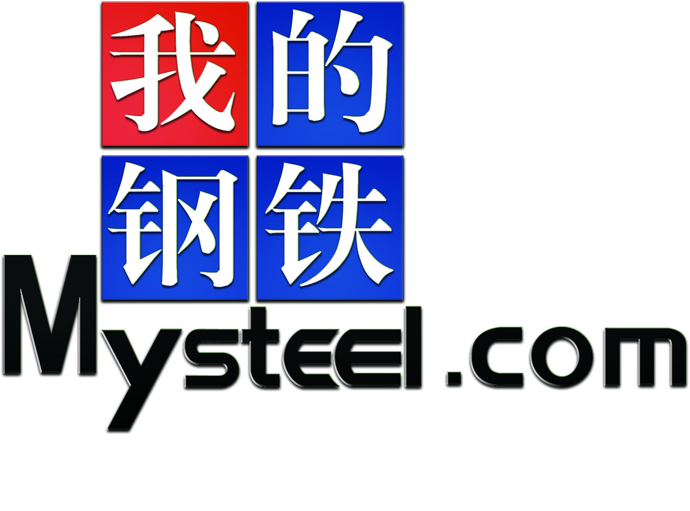 Shanghai Ganglian Information Technology Co.,Ltd
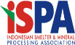 Indonesian Smelter & Mineral Processing Association
Indonesian Research & Development International
Supporters：
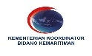 Investment Coordinating Board Republic of Indonesia
Ministry of Energy and Mineral Resources
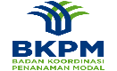 Coordinating Ministry of Maritime Affairs and Resources

Meeting Schedule
Date | Schedule | Place
September 13th（09:00-21:00） | Conference registration | The hotel lobby
September 13th（16:00-18:00） | Meetings for Representatives of domestic and overseas | Bandung Room
September 14th（09:00-17:30） | Meeting | Satoo Garden
September 15th | Indonesian mine and enterprise inspection | Please contact the conference team for details

Conference Agenda

Wednesday , Sep 13th 2017
09:00-21:00 | Conference Registration
09:00-15:00 | All-day Reception
16:00-18:00 | Meetings for representatives of domestic and overseas Bandung Room, 3rd floor
18:30-20:00 | Welcome Banquet Buffet Satoo
Thursday morning, Sep 14th 2017, Satoo Garden
07:00-10:00 | Conference Registration
07:00-09:00 | Guest Entrance
Opening Session:
09:00-09:30 | MC: Mr. Xia, Mysteel.com  Welcome message by Jonny Darmawan, Vice Chairman, Kadin Indonesia  Opening message: Mr. WangLiPing, Minister counseior, China Embassy to Indonesia
Session ONE：Indonesian Government Policy Keynote speeches
09:30-10:15 | - Acceleration of mineral processing sector via Special Economic Zone by Mr. D Nasution, Coordinating Minister for Economic affair, or his Deputy  - Mineral processing industry development by Mr. Erlangga Hartarto, Minister of Ins or Director General  - Questino and amswer
10:15-10:30 | Morning Coffee break
Session TWO：Presentation & High level Dialogue “How to develop Indonesian steel SEZ”
10:30-12:00 | Moderator: Vince Gowan, Kadin Indonesia  ● Government officers: (Some may love to policy session)  ○ Mr. Edy Putra Irawadi, Deputy Minister, Coordinating Ministry for Economic affair  ○ Mr. Putu Surya Wirawan, Dirgen Metal Industry, Ministry of Industry  ○ Mr. Tamba Hutapea, Deputy Chairman, BKPM(Investment of Coordination Board)  ○ Mr. Enoh Suharto Secretary General, Special Economic zone council  ● Industry players  ○ China Steel industry and market trend: Mr. Li Qiang, China Stainless steel Association
Thursday afternoon ,Sep 14th 2017
Session THREE 1:30-3:00 pm “Nickel Source & Smelter”
1:30-3:00 | ● Moderator: Steve Brown / Ladjiman Damanik  ○“China Nickel ore Demand and supply” by Cathy, China Nickel expert  ○“Philippine Nickel ore supply policy and Trend” by Philippine Mine Expert  ○“Indonesian Nickel ore resources and Smelter” by ESDM  Panel discussion: will invite the above speakers and few stake holders; Mysteel. com, Tshingsan, Vale, Antam, Black Space etc.
3:00 - 3:15 | Coffee Break
Session FOUR: 3:15-4:45 pm: Contributing to Successful SEZ
3:15 - 4:45 | ● Moderator: Timmy He / Mr. Xia, Mysteel. com  Port and logistic - Successful steel SEZ models in China and Malaysia  ○ China: Guangxi Beibuwan - Chengde & Malaysia kuantan model  ○ Indonesia: Pelindo / China Harbour Indonesia  Energy resources for Mineral processing  ○ Successful experience in Sarawak, How about North Kalimantan?  Market: Steel industry opportunity and challenge in Indonesia  ○ Krakatau steel development, Jindai steel model  Financing, Tax incentives,LME and Nickel stock exchange  Panel Discussion: above speakers etc.
Closing Remarks: 4:45 - 5:00 PM By DR. Sukhyar, Chairman of ISPA,
Round table Gala Dinner starting 6:30 PM ( Any show / music entertainment?)
Remarks: Other delegation / speakers candidates: Hengsun, Posko Krakatau, xixin Harita, DR. Chandra, Yinyi, Huadi, Shenwu, jinling, lime stone, Indoferro

Meeting Guide
Notes for Application:
There will be no limit on the number of delegates before August 20 and the application representative cannot guarantee entry to the conference list after August 20. The representatives can be replaced if there is a special case. Please specify the "2017 the Belt and Road International Stainless Steel High Level Think Tank Forum " and provide the name of the remittance unit.
The Registration Process：
Fill in the receipt → Fax (or Email / WeChat ) to the office of the organizing committee (or online) → Remittance to the specified account → Receive the confirmation→ registration success
Participation Fee：
Before August 20, Member unit 8000 yuan/person，non-member unit 9000 yuan/person, foreign enterprises ( domestic branches ) 1500 dollar/person ( including admission to prove, meals, materials, gifts, excluding accommodation expenses)
Before August 20, Member unit 9000 yuan/person、non-members unit 10000 yuan/person、foreign enterprises (domestic branches) 1600 dollar/person (including admission to prove, meals, materials, gifts, excluding accommodation expenses)
Accommodation：
Registration Fee doesn’t include the accommodation fee. And conference team get some discount in Shangri-La Hotel Jakarta. If you need reservation, you can check the Application Form of High Level Think Tank FGD Forum, and e-mail us before 1st September. We won’t reserve room if it go beyond the time limit.
Ads Support:
You are welcomed to advertising by supporting our meeting, using our meeting place or our propaganda. Please connect the organization committee office about the details, and you can check the advertising rates on the meeting website. And please hand in the application before the 15th August.

Application Form of High Level Think Tank FGD Forum
Company Name
English Name
Name | Title | Landline Number |  | Phone Number |  |  | E-mail
Room Categories | Shangri-La Hotel Jakarta:  You need ___ King-Size room(1100RMB a room)  from ___ to ___  You need ___ Twin-bed room(1100RMB a room)  from ___ to ___  Fraser Residence Sudirman, Jakarta:  You need ___ Deluxe room(766RMB a room)  from ___ to ___  You need ___ Imperatorial Room(932RMB a room)  from ___ to ___  Ascott Jakarta:  You need ___ Deluxe room(660RMB a room)  from ___ to ___  You need ___ Imperatorial Room(925RMB a room)  from ___ to ___ |  |  |  |  |  | Attention:  - If you need a reservation,  please check the left-hand chart.  ②Please send the form back to us before 20th August. If you have no need of the accommodation.  ③Risk Tips about sharing room: You should pay full price for your room, if one party leave early or check-out late. Ps. Please checkout separately
Member standard | Before August 20th |  | After August 20th |  |  |  | Foreign institutions(including domestic)
Members | 8000RMB/person |  | 9000RMB/person |  |  |  | 1500USD/person
Non-Members | 9000RMB/person |  | 10000RMB/person |  |  |  | 1600USD/person
Investigation  Project | Mine Ferronickel Factory  Steel Mill Corporate Office in Indonesia |  |  |  |  | Investigation Activity: If you want to attend the investigation, you can check the boxes. And the activity will start after the 15th, please check your schedule to arrange your time reasonably.
Registration Fee | Name：Shanghai Ganglian Information Technology Co.,ltd  Bank : CHINA CONSTRUCTION BANK SHANGHAI BRANCH  BAOSHANSUBBRANCH  Bank Address: 1398 Mu Dan Jiang Road Baoshan District shanghai china  NO: 31001529000050008331  SWIFT : PCBCCNBJSHX |  |  |  |  | Attention:  1、Collection unit produce invoices.  2、Please indicate “ 2017 the Belt and Road International Stainless Steel High Level Think Tank Forum ”, and post the form back to us.
Conference Team | Xie xin: 021-26093942/15667270991
Fax | 021-66896936 |  |  |  | Inviter:

