Registration Form
Company: Country: Delegate 1: Title:
Tel: Mob: Email:
Delegate 2:
Title:
Tel:
Mob:
Email:

Bank Account Details Beneficiary: Shanghai Ganglian E-Commerce Co., Ltd.
Bank: BANK OF CHINA
SHANGHAI BRANCH
A/C No.: 4572 5924 0473 (USD)
Swift Code: BKCHCNBJ300
Account No.: 4572 5924 0473

For more information, please
Early Bird Rate before 31st
May, 2017
Single USD
Delegate 1000/delegate
Group USD
above 2 800/delegate

Early Bird Rate before Feb 17, 2016
Single Delegate USD
1200/delegate
Group above 2 USD
1000/delegate

Rate on and after 31st May,
2017
Single USD
Delegate 1100/delegate
Group USD
above 2 900/delegate

Payment at Conference Site
Single USD
Delegate 1200/delegate

Hotel Accommodation

Room Type Rate(room/night)

City Wing Deluxe
Room Single RMB 1080+6%VAT

City Wing Deluxe
Room Double RMB 1280+6%VAT

Valley Wing

contact
Executive Room
Single/Double
RMB 1800+6%VAT

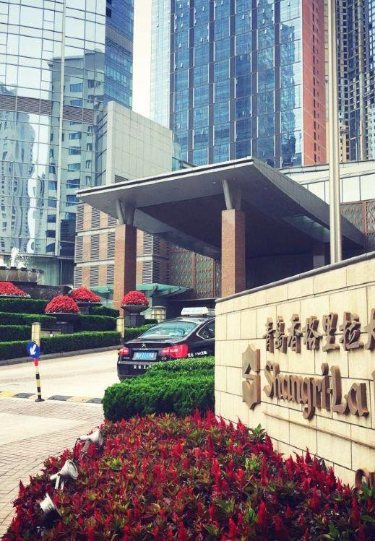
Helen Zhi 021-26093195
18521414209
Zhihl@mysteel.com

Kian Han 021-26094354
18521414225
Hanjr@mysteel.com

To ensure availability of hotel room, delegates who need accommodation reservation must indicate preferred room type and room quantity on the registration form before 31st May. The accommodation charge shall be paid by the delegates to the hotel directly.

